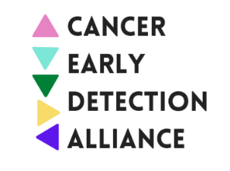

CEDA Applauds Development of National Cancer Plan

The Cancer Early Detection Alliance (CEDA) applauds the U.S. Department of Health and Human Services’ (HHS) release of the National Cancer Plan, developed by the National Institutes of Health’s (NIH) National Cancer Institute (NCI) as a framework for collaboration to accomplish the primary goal of Cancer Moonshot—to end cancer as we know it.

CEDA is a unique collaboration of patient, provider, and industry advocates committed to using its collective voice to identify and advance policies that remove barriers to cancer screening, eliminate racial and ethnic disparities in cancer screening, and improve access to innovations in early cancer detection to save lives.

As an alliance dedicated to improving early cancer screening, we are encouraged to see the National Cancer Plan’s emphasis on cancer prevention, early detection, and eliminating inequities. Of the eight goals, one is directly linked to CEDA’s mission – “detect cancers early.” We are encouraged by the focus on identifying new methods to detect cancer early and identifying barriers, such as financial toxicity and the need for patient navigation services, to treating early-stage cancers in communities experiencing disparities. CEDA looks forward to the Plan’s implementation and coordination across existing early cancer screening research and programs supported by the federal government.

CEDA encourages NCI to work in coordination with other federal agencies and advisory boards to ensure that best practices in cancer prevention, detection, and treatment are implemented at limited or no cost to the general population to facilitate access and decrease cancer disparities and inequities.

